1. INTRODUCTION

An image is basically a two dimensional function of spatial coordinates, f(x, y), and amplitude of this function at a given coordinate gives the intensity value of the image. The image can be expressed as the product of functions of illumination and reflection. f(x,y) = i(x,y) . r(x,y) where i(x,y) is the function of intensity and r(x,y) is the function of reflectivity Digital image processing is application of various algorithms on the image to improve the quality of the image by removing noise & other unwanted pixels and also to obtain more information on the image. Among the various image processing techniques image segmentation is very crucial step to analyse the given image. This paper mainly focuses on this method, the various methods followed and few algorithms that are widely used. An attempt is made to provide the comparison on these methods by taking test images. The images are operated using MatLab software

2. LITERATURE SURVEY

2.1. BACKGROUND OF MATLAB

Matlab is a high performance language for technical computing. It integrates computation, visualization and programming in an easy to use environment where problems and solutions are expressed in familiar mathematical notation. Typical uses included the following-

1. Math and computation
2. Algorithm development
3. Data aquistion
4. Modelling, simulation, and prototyping
5. Data analysis, exploration, and visualization
6. Data analysis, exploration
7. Scientific and engineering graphics
8. Application development, including graphical user interface building

2.2. DIGITAL IMAGE PROCESSING

An image is defined as a two dimensional function f(x,y), where x and y are spatial (plane) coordinates, and the amplitude of f at any pair of coordinates (x,y) is called the intensity of image at that point. The term gray level is used often to refer to the intensity of monochrome images. Color images are formed by a combination of individual 2D images. An image may be continuous with x and y coordinates and the amplitude. Digitizing the coordinate and the amplitude value is called the sampling and quantization respectively and if the x and y and the amplitude value is finite, we call the image as digital.



Representation of digital image

READING IMAGES

Images read in the Matlab as -- imread(‘filename’)



Format of image

Function size gives the row and column dimensions of the image [ Size(f) ], Whos function display additional information about array [ Whos f ], Image can be displayed as,[ imshow(f,g)], f is an image array and g is the intensity of array levels,

[ pixval ] displays the Euclidean distance between the initial and current cursor locations, Images are written in disk using function [ imwrite(f, ‘filename’) ], [ iminfo filename] gives the detail of the image.

2.3. IMAGE SEGMENTATION

Image segmentation is a mid-level processing technique used to analyse the image and can be defined as a processing technique used to classify or cluster an image into several disjoint parts by grouping the pixels to form a region of homogeneity based on the pixel characteristics like gray level, color, texture, intensity and other features. The main purpose of the segmentation process is to get more information in the region of interest in an image which helps in annotation of the object scene**.** Image segmentation aims at domain-independent partition of the image into a set of visually distinct and homogeneous regions with respect to certain properties**.** The main goal of segmentation is to clearly differentiate the object and the background in an image.

If R represents an image, then the image segmentation is simply division of R into sub-regions R1, R2…..Rn, such that and is governed by following set of rules:

a) Ri is a connected set, i=1, 2,…..n.

b) Ri ∩ Rj = Ø for all i and j, i ≠ j

c) Q(Ri) = True for i= 1,2,…n.

d) Q(Ri U Rj) = False for adjoint regions, Ri and Rj

Where Q(Rk) is a logical predicate**.** The rules described above mentions about continuity, one-to-one relationship, homogeneity and non-repeatability of the pixels after segmentation respectively.

There are many knowledge based approaches to segment an image and can be listed as

1. Intensity based methods

2. Discontinuity based methods

3. Similarity based methods

4. Clustering methods

5. Graph based methods

6. Pixon based methods

7. Hybrid methods

In the following sections a brief discussion is made on these methods to understand the principles and extract the attributes from the region of interest. In some literatures segmentation using Markov Random Field are treated as separate segmentation approach, but in this paper it has not discussed directly but have mentioned its application whenever required.

2.4. INTENSITY BASED SEGMENTATION

One of the simplest approaches to segment an image is based on the intensity levels and is called as threshold based approach. Threshold based techniques classifies the image into two classes and works on the postulate that pixels belonging to certain range of intensity values represents one class and the rest of the pixels in the image represents the other class. Thresholding can be implemented either globally or locally. Global thresholding distinguishes object and background pixels by comparing with threshold value chosen and use binary partition to segment the image. The pixels that pass the threshold test are considered as object pixel and are assigned the binary value “1” and other pixels are assigned binary value “0” and treated as background pixels. The threshold based segmentation techniques are inexpensive, computationally fast and can be used in real time applications with aid of specialized hardware**,** where g(x,y) is the output image; i(x,y) is the input image and t is the threshold value.

Local thresholding is also called as adaptive thresholding. In this technique the threshold value varies over the image depending on the local characteristic of the subdivided regions in the image. The algorithm followed for adaptive thresholding can be stated in general as:

1. Divide the image into sub-image.

2. Choose a local threshold for sub-image considered.

3. Compare the pixels in that sub-image and segment the region.

4. Consider all sub-images individually and choose corresponding threshold values.

5. Stop segmentation when all the sub-images are processed.

In case of global thresholding the threshold value chosen remains the same for the entire image and acts as a cut off‟ value. In case of local thresholding the image is to be subdivided in to sub-images and the threshold is to be chosen depending on the properties of local pixels in that sub-image.

Threshold value can be modified and are categorized as band thresholding, multi-thresholding and semi-thresholding. Either the global thresholding or local thresholding yield the result depending on the value of threshold chosen. Hence the choice of threshold is crucial and complicated. There are several methods employed for detection of threshold value to name a few mean method, p-tile- thresholding, bimodal histogram, optimal thresholding, multispectral thresholding, edge maximization method.Of the available techniques for threshold based segmentation, threshold selection based on the histograms suggested by Nobuyuki Otsu in 1979 is most used with minor modifications. Otsu method is optimal for thresholding large objects from the background. This method provides an optimal threshold (or set of thresholds) selected by the discriminant criterion by maximizing the discriminant measure η (or the measure of separability of the resultant classes in gray levels).

The other approaches employed to select threshold value are histogram based methods, clustering based methods, mutual information based methods, attribute based methods and local adaptive segmentation based methods. The following results compare these techniques.

Pros of threshold based methods:

1. Computationally inexpensive

2. Fast and simpler to implement

3. Can work in real-time applications

Cons of threshold based algorithms:

1. Neglects the spatial information of the image.

2. Highly noise sensitive.

3. Selection of threshold value is crucial and often results in over or under segmentation.

4. May lead to pseudo edges or missing edges.

2.5. DISCONTINUITY BASED METHODS

These methods are based on the principle of intensity variations among the pixels. If the image consists two or more objects boundaries exists and hence can be applied to segment the image. The boundaries of the objects lead to formation of edges. The significant abrupt changes in the intensity levels among neighbouring pixels in certain direction are termed as edges and results in the discontinuity in the pixels. Edge detection basically involves the following steps: smoothing the image, edge detection and edge localization.A suitable smoothing filter is applied on test image to remove the noise from the image to make it suitable for segmentation. Then the „possible‟ edges are grouped together to check for candidature and finally the „true‟ edges are found by localizing the edge „candidates‟. There are four different edge types that may be present in the image (a) step-edge (b) ramp edge (c) ridge edge and (d) ramp edge and are shown in the fig correspondingly**.** Edges are usually found by applying masks over the image. The gradient or the zero crossing techniques are employed to find the edges in the given image. The convolution operation between the mask and the image determines the edge set for the image. Edge detection operators can be broadly classified into two categories as: First order derivative operators and second order derivative operators



A. First order derivative operators:

There are two methods for first order derivative edge detection. 1) One of the methods is evaluating the gradients generated along two orthogonal directions. 2) The second approach is utilizing a set of discrete edge templates with different orientations. [tzu_lee]The first derivative operator uses gradient method to find the edges by using the maximum and minimum value of the gradient. The gradient is a measure of change in a function. Direction of gradient is given by α is measured with respect to x axis. The operators used in this category are Rober’s operator, Prewitt’s operator and Sobel’s operator.

i. Robert’s operator: It is the simplest first derivative operator that can be used to find the edges in the given images. It finds the edges in row and columns separately and are put together to find the resultant edge. The masks used to solve the purpose along x and y direction respectively are

ii. Prewitt’s operator: This operator uses 3 X 3 mask to find the edges. The mask used along x and y direction correspondingly are

iii. Sobel’s Operator: This is widely used first derivative operator to find edges and is modification of Prewitt’s operator by changing the centre coefficient to „2‟. The sobel operators are given as

iv. The Frei-Chen mask: is another operator used to find the edges in the image and its corresponding masks are given as



Impulse response arrays for 3  3 orthogonal differential gradient edge operators.

B. Second Order Derivative operators:

These operators work on zero crossing detection of the second derivative of the gradient. It detects the local maxima in gradient values and treats them as edges. The Laplacian operator is used with the second derivative operator. The Laplacian operator for any function f(x, y) is given by Where

The frequent used second derivative operators for edge detection are Laplacian of Gaussian (LoG) operator and Canny edge operator.

i. Laplacian of Gaussian Operator:

The Laplacian of an image highlights regions of rapid intensity change. The operator normally takes a single gray level image as input and produces another gray level image as output. [raman_maini]. The kernels used for approximation of second derivatives Laplacian operations are

ii. Canny Edge Operator:

Canny edge operator is considered as superior edge detection operator among the available operators based on the experimental results as it determines strong and weak edges in the image. Image is first smoothed by using circular two-dimension Gaussian function, computing the gradient of the result and then using the gradient magnitude and direction to approximate edge strength and direction at every point. The gradient magnitude array so obtained consists of undesirable ridges around local maxima and are to be suppressed to get discrete orientations of the edge normal by the process of non-maxima suppression. Then the technique of double thresholding is employed to reduce false fragments. Two thresholds are used to solve the purpose T1 and T2 where T2 ≈ 2T1. The following results compare the above said methods to segment image using edge operators

Pros:

1. Second order operators give reliable results.

2. Useful in calculating the number of different objects present in the given image.

Cons:

1. No single operator can fit for all variety of images and the computational complexity increases with the size of operator.

2. Many a times the edges obtained are not continuous.

2.6. REGION BASED SEGMENTATION

This method works on the principle of homogeneity by considering the fact that the neighbouring pixels inside a region possess similar characteristics and are dissimilar to the pixels in other regions.

The objective of region based segmentation is to produce a homogeneous region which is bigger in size and results in very few regions in the image. The regions though treated as homogeneous in nature but there is provision to note any considerable changes in the characteristic of the neighbouring pixels.

The simplest approach to segment image based on the similarity assumption is that every pixel is compared with its neighbour for similarity check (for gray level, texture, color, shape). If the result is positive, then that particular pixel is “added” to the pixel and a region is “grown” like-wise. The growing is stopped when the similarity test fails.

Region based methods are fundamentally divided as

1. Region growing methods

2. Region split and merge methods

Further there are several segment approaches based on regional analysis of the image proposed by similarity measures among the neighbours, comparing the pixel to original seed, comparing the pixel to neighbour in region, comparing the pixel to the region statistics, considering multiple seeds, calculating the cumulative differences and counter examples.

A. Region growing methods:

Region growing method gives reliable output compared to its other counterparts. It is basically extracting a region from the image using some pre-defined criteria. The simplest procedure is to compare the candidate pixel to its neighbours to check the homogeneity criteria allocated to the class to which its neighbour belongs. It can be further classified as seeded region growing method (SRG) and unseeded region growing method (UsRG). The main difference between SRG and UsRG is that SRG is semi-automatic in nature whereas UsRG is fully automatic in nature.

i. Seeded Region Growing method:

It was initially proposed by Rolf Adam and is found to be reliable since then. SRG has characteristics like robustness, rapidness and is also free of tuning parameters which makes it suitable for large range of images. In this approach initially the seeds are to be specified by the user. A seed is a test pixel with ideal characteristic that belongs to the region interested in and should be the part of region of interest. The choice of seed is very crucial since the overall success of the segmentation is dependent on the seed input.

The seed set may have one or more members and is user’s choice. For the given set of seeds, each step in the SRG adds pixels to one of the seed sets. In some approaches of SRG these seeds may be replaced by centroids of the segmented regions. The allocated pixels of same region are labelled with same value and other unallocated pixels with different value.

The process is semi-automatic in nature since it depends on user for seed specification.

There are several algorithms available for SRG approach. They all differ in the sense of adding pixels to a region and/or comparing the pixel with the seed. The general steps in SRG algorithm can be as follows:

1. Determine seeds to start the segmentation process.

2. Determine the criteria to grow the region. In case of multiple regions, clearly the characteristic of regions should be mentioned. So that no ambiguity exists to place the pixel in particular region.

3. The candidate pixels to include in the region it should be 8-connected to at least` one of the pixel in the region.

4. Cross-check is to be done to ensure all the pixels are tested for allocation and then label has to be given to all regions.

5. If two different regions get same label then they have to be merged.

The characteristics that are usually considered for the test of homogeneity of the region are gray level, color, texture, shape etc.

ii. Unseeded Region Growing method:

Unseeded region growing method is flexible, automatic segmentation approach and is based on postulate of pixel similarities within regions. UsRG does not rely on tuning parameters and is also independent of manual inputs. This approach readily incorporates the high-level knowledge of the image and is very crucial for the choice of region statistics. The incorporation of basic adaptive filtering techniques have shown some good results in practical [37]. The following are general considerations:

1. Segmentation process is initialized with region A1 containing single pixel and eventually results in several regions (A1, A2, A3…..An) after the completion.

2. Difference measure of the test pixel with the mean value of the region statistics considered decides the pixel to be allocated or unallocated to that region.

3. If the difference value between the test pixel and the region statistics is less than certain threshold considered the pixel is allocated to that specific region, say Aj

4. If the condition is not satisfied than the pixel considered should be allocated to new region, say Ai which has regional characteristic similar to the test pixel.

5. If for any test pixel if the conditions for Ai and Aj are not satisfied then it implies that the test pixel belongs to a new third region and so on and so forth.

B. Region Split and Merge method:

This method is the most similar method to segment the image based on homogeneity criteria. This method works on the basis of quad trees and main objective is to distinguish the homogeneity of the image. It initially considers the entire image as one single region and then divides the image into four quadrants based on certain pre-defined criteria. It checks the quadrants for the same defined criteria and divides it further into four quadrants if the test result is negative and the process continues till the criteria is satisfied or no further division is possible. The figure given below illustrates the process and also the algorithm is given

Algorithm: Let R represent the entire image region and let P be any predicate.

If P(R) == False

Divide the image into quadrants

If P if false for any subquadrant

Subdivide that quadrant into subquadrant.. Stop dividing when P is true. Merge the regions Rj & Rk (j ≠ k; j=1,2,3…n, k=1,2,3…n) if P( Rj U Rk) == true

Fig: Results of region growing algorithms for segmenting images. Pros:

1. Gives superior results compared to other segmentation methods.

2. Provides flexibility to choose between interactive and automatic techniques to segment the given image.

3. Since it flows from inner point to outer region more likely to get clear boundary for the objects.

4. If proper seed is selected it gives very accurate result than any other methods.

Cons:

1. Formulation of Stopping rule for segmentation is a tedious task..[43]

2. SRG can result in scan-order dependencies and can have significant impacts on small regions.

3. A good segmentation result depends on a set of “correct” choice for the seeds and can lead to erroneous segmentation results if user specifies a noisy seed.

4. The seed selection process in itself requires manual interventions, and is error-prone.

The following table gives a comparison of the segmentation methods discussed. The parameters considered for the comparison are random in nature to aid the comparison between the approaches used. The corresponding entries are based on the observation of the result images shown above in discussion.

|  |  |  |  |
| --- | --- | --- | --- |
| Image Segmentation Methods: A Comparative Study Parameter | Threshold Based Segmentation | Edge Based Segmentation | Region Based Segmentation |
| Nature of the Output Image | Black-White | Black-White | Black-White |
| Spatial Information | Neglected | Neglected | Considered |
| Region-Continuity | Moderate | Moderate | High |
| Computation Complexity | Less | Moderate | High |
| Speed | Fast | Moderate | Slow |
| Noise Immunity | Less | Less | Less |
| Detection of Multiple objects | Poor | Poor | Moderate |
| Automaticity | Interactive (Semi Automatic) | Interactive | Interactive (Semi Automatic) |
| Accuracy | Moderate | Moderate | Good |

2.7. CLUSTERING BASED METHODS

Clustering a process of organizing the groups based on its attributes. [santhanu&viki]. The objective of clustering techniques is to identify bunch in data. A cluster usually contains a group of similar pixels that belongs to a specific region and different from other regions. The term data clustering as synonyms like cluster analysis, automatic classification, numerical taxonomy, botrology and typological analysis [Soni madhulatha]. Images can be grouped based on its content. In content based clustering, grouping is done depending on the inherited characteristics of the pixels like shape, texture etc. There are various clustering techniques employed, the most widely used are K-means algorithm and fuzzy C-means algorithm. The Clustering methods are usually divided as hierachical algorithms and partitional algorithms.

A. Agglomerative clustering:

This is a hierarchical approach and starts grouping by calling each data point a separate cluster, and then merges the appropriate clusters into single clusters. The key step for hierarchical algorithms is to compute the distance. This process can be schematized using dendograms. The result of this method is that it results in several partitions. The dissimilarity matrix is used to decide which clusters are to be merged; the smallest entry gives the data points that are least dissimilar and hence are the most likely candidates to be merged.

Algorithm: Agglomerative Hierarchical clustering

1. Select the biggest similarity value from the input similarity matrix and its session is Si,Sj and combine and form its composition Si,j.

2. Form a matrix with Si,j.

3. Find the cell value of matrix as Similarity(Si,j, Sk) = min { similarity (Si,Sk), Similarity(Sj,Sk)}

4. Repeat step 2 until single cluster in matrix cell.

B. Partitional clustering:

These algorithms works by specifying the number of groups initially and converging them iteratively.The partitional clustering divides the data points into clusters such that the total distance of data points to their respective cluster centers is minimal. An algorithm to achieve this is called Kmeans clustering. The partitional clustering results in one single partition of the image.

1. K-means algorithm
2. This algorithm clusters the point nearest to the centroid. The centroid is basically the average of all the points in that cluster and has coordinate as the arithmetic mean over all points in the cluster, separately for each dimension.

Algorithm: K-means clustering

1. Select the number of desired clusters k. Arbitrarily place the k cluster centers at different initial locations in the image.

2. Assign each data point to the cluster whose center is closest.

3. Recompute the cluster centers; the cluster center should be at the average coordinates (center of gravity) of the data points that make up the cluster.

4. Go to step 2 until no more changes occur or a maximum number of iterations is reached.

This algorithm minimizes the total distance of data points to the cluster center, of the cluster they are assigned to. Also it does not require the actual computation of distances. A drawback of k-means algorithm is that the number of desired clusters needs to be set before. Although hierarchical methods can be more accurate, partitional methods are used in applications involving large data sets (related with images) due to the fact the construction of a dendrogram is computationally prohibitive.[4]. In hierarchal method if once the merge/split is done, it can never be undone. This rigidity can be limitation in some case and can be useful in other as it leads to smaller computation costs by not worrying about a combinatorial number of different choices.

1. Fuzzy C-Means [FCM] Algorithm:

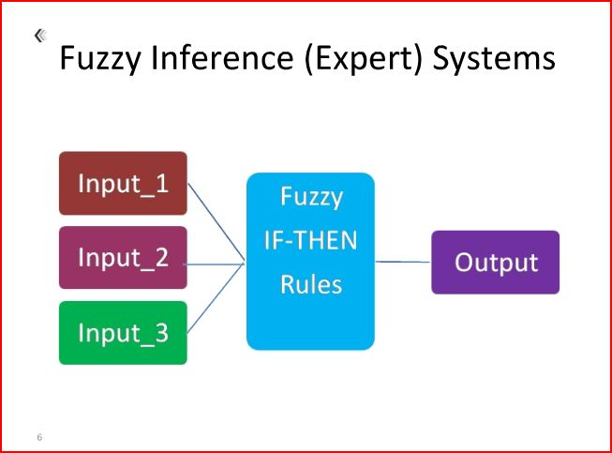

In this algorithm the test pixel is allowed to be member of two or more clusters with different membership coefficient. FCM algorithm is iterative in nature and generates fuzzy partition matrix and also requires cluster centre along with objective function. The values for cluster centre and objective function are updated for every single iteration and are stopped when the difference between two successive object function values is less than some predefined threshold value. The objective function and the algorithm are as given below. Where x={x1,x2,x3,……….,xn}⊆ R; dataset n= number of data items c= number of clusters; 2 ≤ c < n = degree of membership of xk in ith cluster q= weighting exponent of each fuzzy member = prototype of center cluster. 90 = distance between object and cluster center

The fuzzy C-Means algorithm (FCM) generalizes the hard c-mans algorithm to allow a point to partially belong to multiple clusters. Therefore, it produces a soft partition for a given dataset. In fact, it produces a constrainedsoft partition. To do this, the objective function *J1* of hard c-means has been extended in two ways:

(1) The fuzzy membership degrees in clusters were incorporated into the formula, and

(2) An additional parameter *m* was introduced as a weight exponent in the fuzzy membership.

The extended objective function [3], denoted *Jm*, is:

$$J_{m}\left(P,V\right)=\sum_{j=1}^{c}{\sum_{x_{i}∈C_{j}}{{{(μ_{C_{i}}\left(x_{k}\right))}^{m}|\left|x_{k}-v_{i}\right||}^{2}}}$$

where *P* is fuzzy partition of the dataset *X* formed by *C1,C2,…,Ck*. The parameter *m* is a weight that determines the degree to which partial members of a clusters affect the clustering result.

Like hard c-means, fuzzy c-means also tries to find a good partition by searching for prototypes *vi* that minimize the objective function *Jm*. Unlike hard c-means, however, the fuzzy c-means algorithm also needs to search for membership functions $μ_{C_{i}}$ that minimize *Jm*. To accomplish these two objectives, a necessary condition for local minimum of *Jm* was derived from *Jm*. This condition, which is formally stated below, serves as the foundation of the fuzzy c-means algorithm.

**Theorem.** Fuzzy c-means theorem. A constrained fuzzy partition {*C1,C2,…,Ck*} can be a local minimum of objective function *Jm* only if the following conditions are satisfied:

$μ_{C_{i}}\left(x\right)=\frac{1}{\sum_{j=1}^{k}{{(\frac{{\left|\left|x-v_{i}\right|\right|}^{2}}{{\left|\left|x-v_{j}\right|\right|}^{2}})}^{\frac{1}{m-1}}}}$ 1≤ i≤ k, $x∈X$

$v_{i}=\frac{\sum_{x∈X}{{(μ_{C_{i}}\left(x\right))}^{m}x}}{\sum_{x∈X}^{n}{{(μ_{C_{i}}\left(x\right))}^{m}}}$ 1≤ i≤ k

Based on this theorem, FCM updates the prototypes and the membership function iteratively using equations 2 and 3 until a convergence criterion is reached. We describe the algorithm below.

FCM (*X, c, m,* ε*)*

*X*: an unlabeled data set.

*c*: the number the clusters.

*m*: the parameter in the objective function

ε: a threshold for the convergence criteria.

Initialize prototype V={*v1,v2,…,vc*}

Repeat

*VPrevious* ← *V*

Compute membership functions using equations 3.

Update the prototype, *vi* in *V* using equation 2.

Until $\sum_{i=1}^{c}{|\left|v_{i}^{previous}-v_{i}\right||≤ε}$.

Algorithm steps:

* Choose a number of clusters.
* Assign randomly to each point coefficients for being in the clusters.
* Repeat until the algorithm has converged (that is, the coefficients' change between two iterations is no more than ε, the given sensitivity threshold) :
  + Compute the centroid for each cluster, using the formula above.
  + For each point, compute its coefficients of being in the clusters, using the formula above.

In addition of above, the hybrid of the k-means algorithm and fuzzy c-means algorithm also exists and is called as fuzzy k-c means algorithm and it resembles fuzzy c-means algorithm in most situations but with improved efficiency. The comparison between these algorithms is given in . Clustering algorithms use many different features of images like brightness (pixel intensity) and geometric information (pixel location), though an algorithm’s effectiveness is very dependent on the type of object and the feature used. This raises ambiguity among the choice of features to obtain better results for given image and hence limit the generalization of a clustering algorithm.

2.8. HYBRID METHODS

Hybrid methods combine one or more of the basic segmentation methods. These algorithms inherit the good quality of several approaches and gives better performance compared to its parent approach. The combination of threshold based and clustering methods [2] are used in medical image segmentations along with the region-edge based approaches[35], region –deformable models [Fresno et al], region-edge-based with morphological watershed [15]. Hybrid methods rely on morphological operations performed on images. The widely used techniques are watershed segmentation, variable-order surface fitting and active contour methods.

A watershed region is defined as the region over which all points flow “downhill” to a common point.

The watershed algorithm uses concepts from edge detection and mathematical morphology to partition images into homogeneous regions [22] and is applied to the gradient magnitude of the image. The gradient image can be considered as topography with boundaries between regions as ridges. This method produces closed boundaries when transition between regions is of variable strength or sharpness. Let M1, M2, …, MR sets denoting the coordinates in the regional minima of an image g(x, y), where g(x, y) is the pixel value of coordinate (x, y). Denote C(Mi) as the coordinates in the catchment basin associated with regional minimum Mi. Finally, let T[n] be the set of coordinates (s, t) for which g(s, t) < n and show as T[

The boundary values of the pixels of g(x,y) is to be found and the minimum value is to be assigned to Mi. Start flooding by initializing n=min+1 (min corresponds to the minimum boundary value). Let Cn(Mi) as the coordinates in the catchment basin associated with minimum Mi that are flooded at stage n. Step2. Compute Cn(Mi) = C(Mi) ∩T[n] Then let C[n] denote the union of the flooded catchment basins at stage n: Set n = n + 1. Step3. Derive the set of connected components in T[n] denoting as Q. For each connected component q Q[n], there are three conditions: a. If is empty, connected component q is incorporated into C[n - 1] to form C[n] because it represents a new minimum is encountered. b. If contains one connected component of C[n - 1], connected component q is incorporated into C[n - 1] to form C[n] because it means q lies within the catchment basin of some regional minimum. c. If contains more than one connected component of C[n- 1], it represents all or part of a ridge separating two or more catchment basins is encountered so that we have to find the points of ridge(s) and set them as “dam”. Step4. Construct C[n] using the values obtained for Cn(Mi) and c[n] Set n = n + 1. Step5. Repeat Step 3 and 4 until n reaches max + 1. Cons: The method suffers from over-segmentation, i.e. the image is segmented into an unnecessarily large number of regions. So watershed algorithms usually followed by a post-processing step to merge separate regions that belong to the same. [22] Watershed algorithm gives a connected edge component at the cost of computational time. Watershed algorithm encounters difficulties with images in which regions are both noisy and have blurred or indistinct boundaries. The variable-order surface fitting method starts with a coarse segmentation of the image into several primitives, which are refined by iterative region growing procedure. Active contour models are based on gradient information along the boundary between regions, but they are useful only when a good initial estimate is present.

2.9. GRAPH BASED METHODS

Graph based methods for image segmentation has several good features in practical applications. It explicitly organizes the image elements into mathematically sound structures, and makes the formulation of the problem more flexible and the computation more efficient.[40].

Let G = (V, E) be a graph where V ={ v1 ,..., vn } is a set of vertices corresponding to the image elements, which might represent pixels or regions in the Euclidean space. E is a set of edges connecting certain pairs of neighboring vertices. Each edge (vi,vj)∈ E has a corresponding weight w(vi,vj) which measures a certain quantity based on the property between the two vertices connected by that edge. In the case of image segmentation, the elements in V are pixels and the weight of an edge is some measure of the dissimilarity between the two pixels connected by that edge (e.g., the difference in intensity, color, motion, location or some other local attribute).[pedro & daniel] An image can be partitioned into mutually exclusive components, such that each component A is a connected graph G = (V, E), where V′⊆ V, E′⊆ E and E' contains only edges built from the nodes of V'. In other words, nonempty sets A1, …, Ak form a partition of the graph G if Ai∩Aj =φ (i,j∈ {1, 2, …, k}, i≠j) and A1∪…∪Ak=G. The graph based methods are categorized into five classes : the minimal spanning tree based methods, graph cut based methods with cost functions, graph cut based methods on Markov random field models, the shortest path based methods and the other methods that do not belong to any of these classes.[40] Among the available techniques graph cut methods are widely used and was initially proposed by yuri and marie[34]. Using the definition of graph theory, the degree of dissimilarity between two components can be computed in the form of a graph cut. Graph cut formalism is well suited for segmentation of images. [34]. A cut is a subset of edges by which the graph G will be partitioned into two disjoint sets A and B and the cut value is usually defined as: where u and v refer to the vertices in the two different components. The cost function is defined in terms of boundary and region properties of the segments. These properties can be viewed as soft constraints for segmentation.

Image courtesy [34]

Consider an image as shown in the above fig 1(a). Using the object and background seeds create a graph with two terminals as shown in 1(b) and by using the edge weights, boundary terms of cost function and positions of seeds in the image separate two terminals by computing optimal minimum cut 1(c). This cut would give the segmentation result as shown in 1(d). There are various other methods that are used to obtain desired image segmentation using the graph theory. A detailed survey on graph based techniques is done by ping et.al [40] and the reader can refer for more detailed information. The advantage of the segmentation using a graph based approach is that it might require no discretization by virtue of purely combinatorial operators and thus incur no discretization errors.

2.10. PIXON BASED METHOD:

The pixon method is a nonlinear image reconstruction method that has decision levels as pixons instead of pixels. This method increases linear spatial resolution by few factor and sensitivity by the order of magnitude. [puetter]. This was introduced by pina & puetter in 1993. Another advantage of pixon based method is computational fastness compared to other methods. There are various ways to select pixons locally convolving the kernel with the pseudo image, using anisotrophic diffusion equations and combining with Markov Random Fields [Yang & Jiang]Fast Quad Tree Combination algorithm can be used to get good pixon representation and can be combined with MRF model [Lei Lin et al], another method can be wavelet thresholding is used as preprocessing step by Hassanpour et al and then proper pixon representation is extracted using suitable algorithm and finally segmented using Fuzzy-C Means algorithm[Hassanpour et al]. Pixon based methods can be classified as Traditional Pixon Based method, MRF model Pixon Based method and Wavelet threshold Pixon Based methods. Traditional Pixon Based method is simple to approach and has only two steps of forming pixons and segmenting the image. Forming the pixon in this method has three steps: (i) achieve a pseudo image with same resolution as the observed image (ii) filter using anisotrophic diffusion filter to achieve pixons (iii) use hierarchical clustering algorithms to extract pixons. After extracting the pixons, pixon-based image model is represented by a graph structure and the segmentation problem is transformed into problem of labeling pixons. In this method the final segmented image is obtained by combining the pixons until the given end condition occurs.[Hassanpour et al] In MPB model the image is first represented as pixon-based model. The pixons are combined to their attributes and adjacencies (pixons and edges). Using this pixon representation a MRF model is presented to segment the images. Bayesian framework is to be done to segment the image. A FQTC algorithm can be used to extract good pixon representation. In WPB method, wavelet thresholding is done on the image to reduce unnecessary details in the image, as a result the number of pixons also reduces to make performance faster. Then the image is considered as pixonal model and then segmented using fuzzy c-means clustering algorithm

III. OBJECTIVE AND SCOPE OF THE WORK

The segmentation of the image is very useful in medical applications to diagnose the abnormalities in the image, satellite imaging and in computer vision as well as in ANN. The criteria for segmenting the image is very hard to decide as it varies from image to image and also varies significantly on the modality used to capture the image. There is large amount of literature available to understand and analyse the segmentation techniques.

In the clustering methods have been discussed for medical image segmentation in particularly for MR Images of brain and are successful in combining fuzzy c means and k-means to get novel fuzzy-k means algorithm. Few limitations of the obtained algorithm have been also stated.

Hybrid technique for medical image segmentation is suggested in and mainly works on fuzzy-c means and otsu’s method after applying on vector median filter, for segmentation and have tried to prove the robustness of their method few kinds of noise have been added to image and have obtained satisfactory results.

A new technique for general purpose interactive segmentation of N-dimensional images using graph-cut method has been proposed by Yuri and Jolly. In their proposed method the user marks certain pixels as “object” or “background” to provide hard constraints for segmentation.

They claim that their method gives best balance of boundary and region properties compared to other segmentation methods and also that it provides optimal solution for N-dimensional segmentation.

The list of related works done in the field of image segmentation is very large and can hardly be mentioned. There are various survey and reviews done on these methods periodically. The following sections gives brief principle followed to segment images

IV. EXPERIMENTAL MATLAB CODES AND RESULT

Contrast stretching

I = imread('C:\Users\Ashish Verma\Desktop\LEENA.png');

I2=im2double(I);

m=mean2(I2);

contrast1 = 1./(1 + (m ./(I2 + eps )).^4);

contrast2 = 1./(1 + (m ./(I2 + eps )).^5);

contrast3 = 1./(1 + (m ./(I2 + eps )).^10);

contrast4 = 1./(1 + (m ./(I2 + eps )).^-5);

contrast5 = 1./(1 + (m ./(I2 + eps )).^-1);

figure, imshow(I2)

figure, imshow(contrast1)

figure, imshow(contrast2)

figure, imshow(contrast3)

figure, imshow(contrast4)

figure, imshow(contrast5)

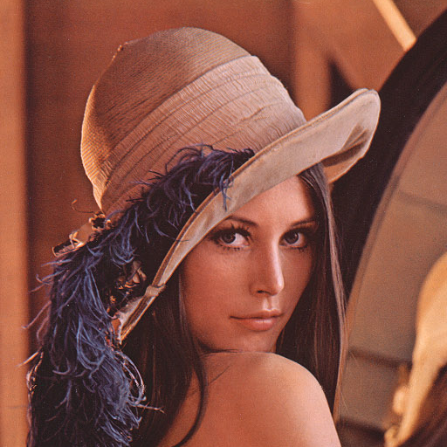 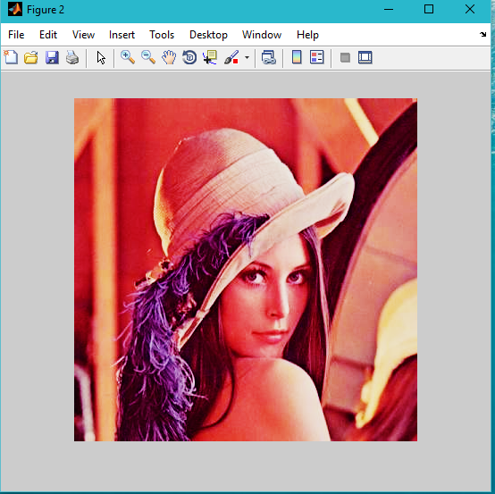

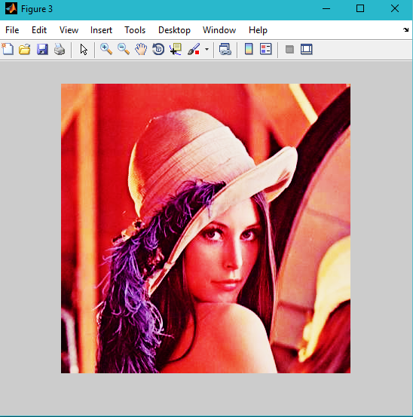 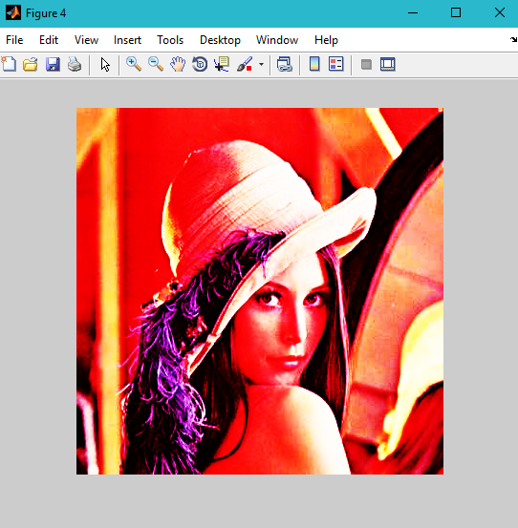

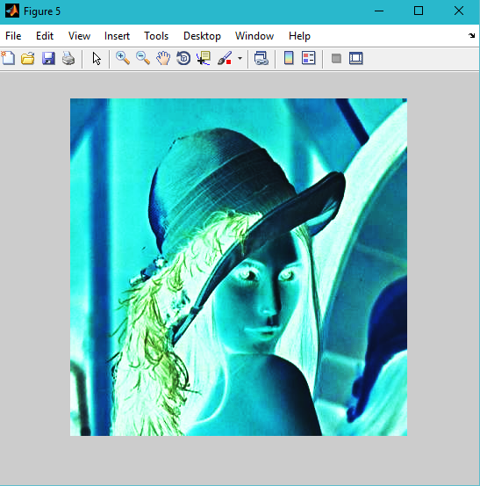 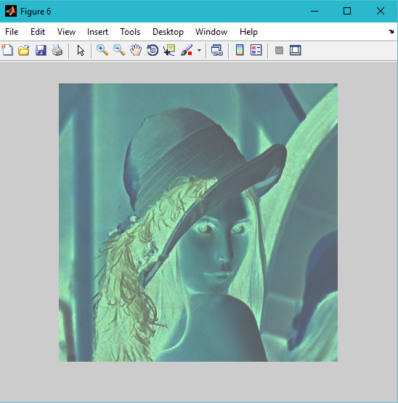

Complement image

I = imread('C:\Users\Ashish Verma\Desktop\LEENA.png');

J=imcomplement(I);

figure,imshow(J)

 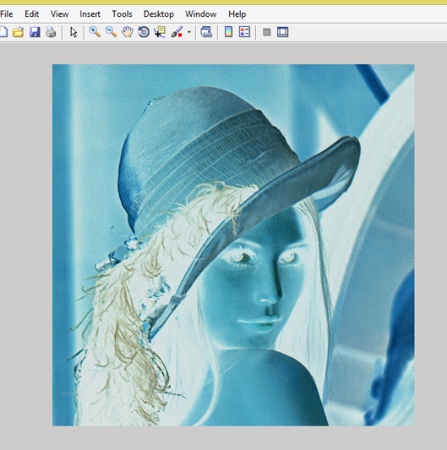

ORIGINAL IMAGE COMPLEMENT IMAGE

RGB

I = imread('C:\Users\Ashish Verma\Desktop\LEENA.png');

R = I(:,:,1);

figure;

image(R),colormap([[0:1/255:1]',zeros(256,1),zeros(256,1)]), colorbar;

G = I(:,:,2);

figure;

image(G),colormap([zeros(256,1),[0:1/255:1]',zeros(256,1)]), colorbar;

B = I(:,:,3);

figure;

image(B),colormap([zeros(256,1),zeros(256,1),[0:1/255:1]']),colorbar;

 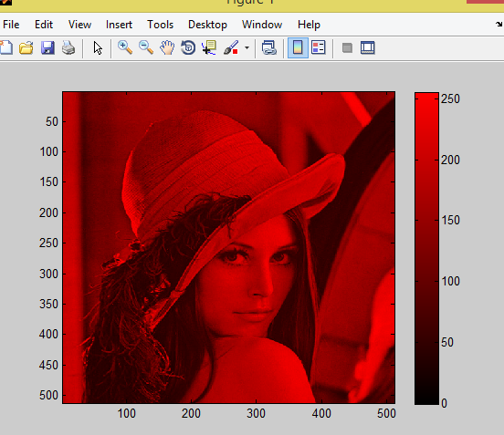

Original image output 1

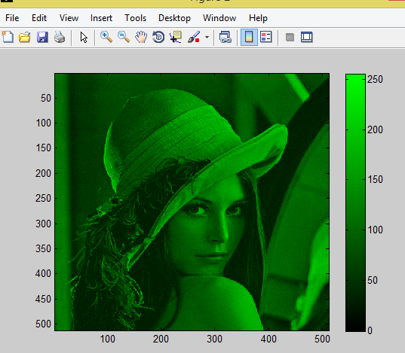 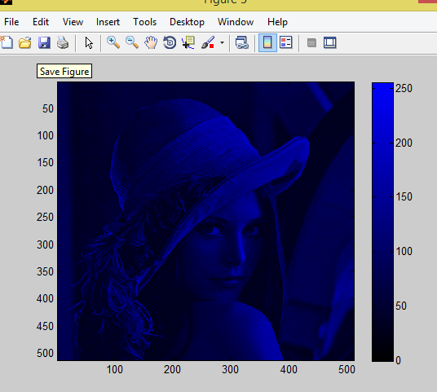

Output 2 output 3

WATERSHED SEGMENTATION

I = imread('C:\Users\Ashish Verma\Desktop\LEENA.png');

I=rgb2gray(I);

hy = fspecial('sobel');

hx = hy';

Iy = imfilter(double(I), hy, 'replicate');

Ix = imfilter(double(I), hx, 'replicate');

gradmag = sqrt(Ix.^2 + Iy.^2);

figure, imshow(gradmag,[]), title('Gradient magnitude (gradmag)')

L = watershed(gradmag);

% Lrgb = label2rgb(L);

figure, imshow(L), title('Watershed transform of gradient magnitude (Lrgb)')

 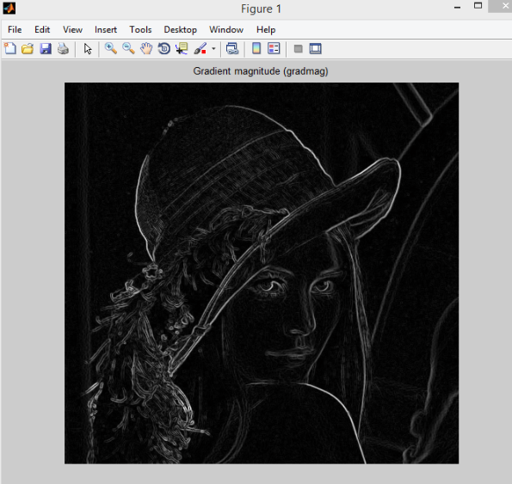

Original image output 1

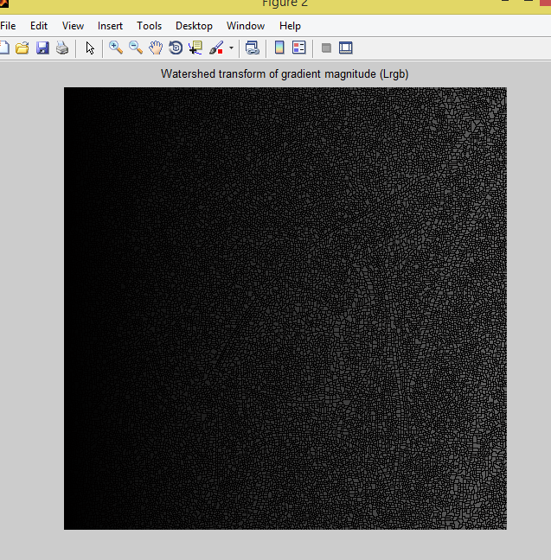

Extraction of image

I = imread('C:\Users\Ashish Verma\Desktop\LEENA.png');

x=double(I)

figure, imshow(x)

impixelinfo;

figure, imshow(I);

impixelinfo;

x(20,20);

c0=mod(x,2);

c01=mod(I,2);

figure, imshow(c0)

figure, imshow(c01);

c1=mod(floor(x/2),2);

c2=mod(floor(x/4),2);

c3=mod(floor(x/8),2);

c4=mod(floor(x/16),2);

c6=mod(floor(x/32),2);

c7=mod(floor(x/64),2);

c8=mod(floor(x/128),2);

figure, imshow(c1);

figure, imshow(c2);

figure, imshow(c3);

figure, imshow(c4);

figure, imshow(c6);

figure, imshow(c7);

figure, imshow(c8);

 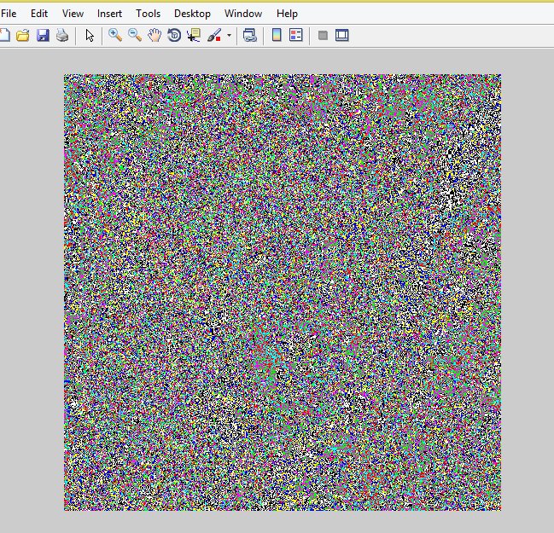

 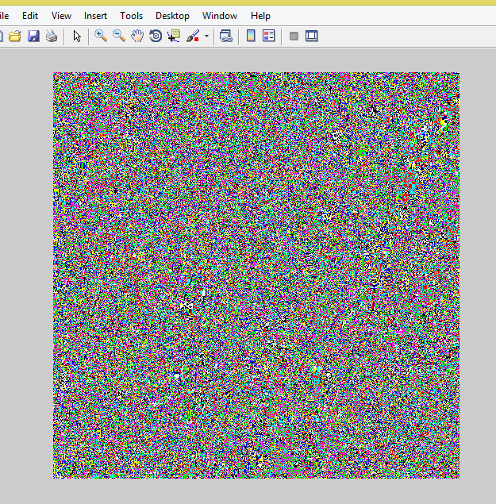

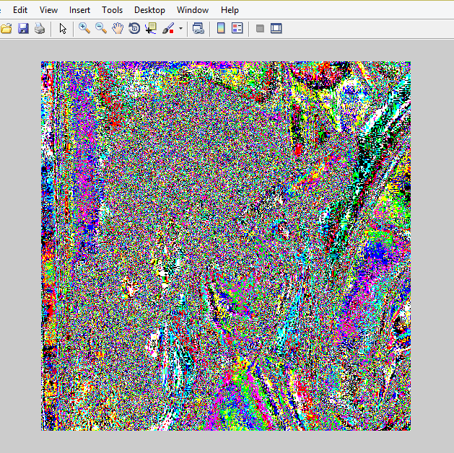 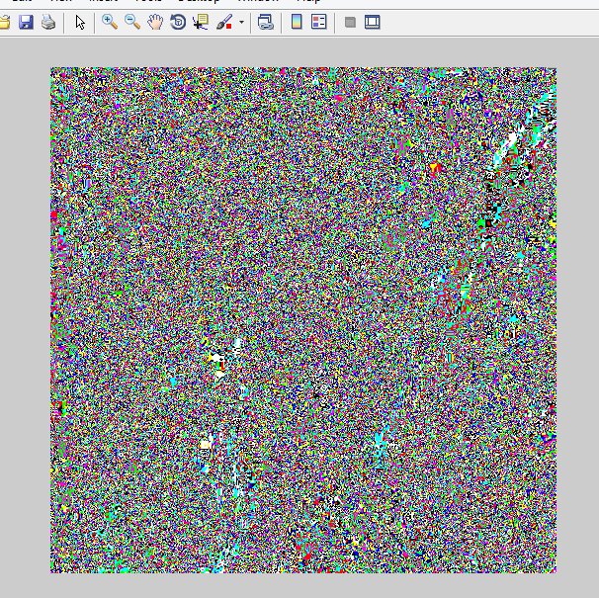

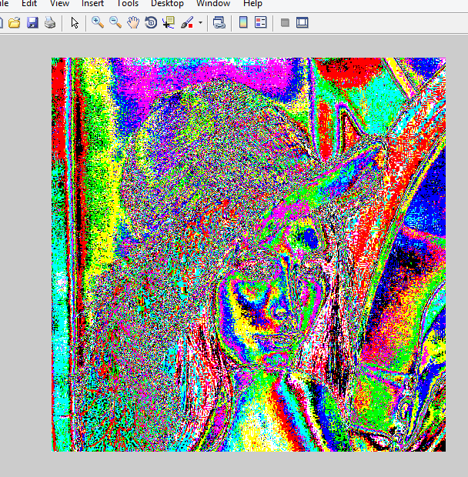 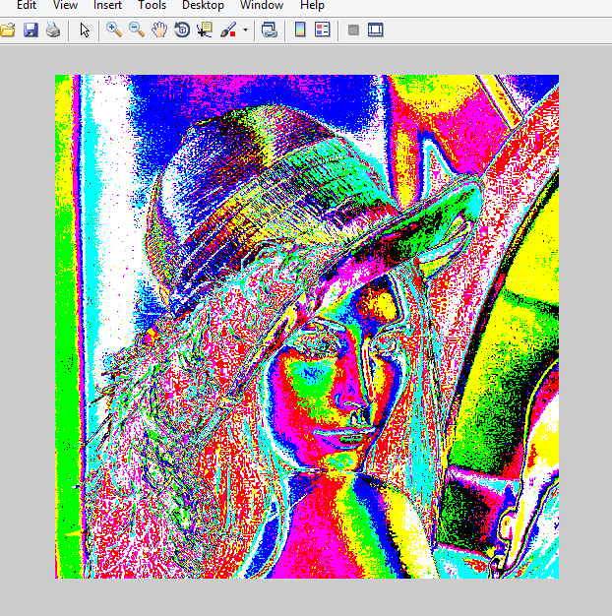

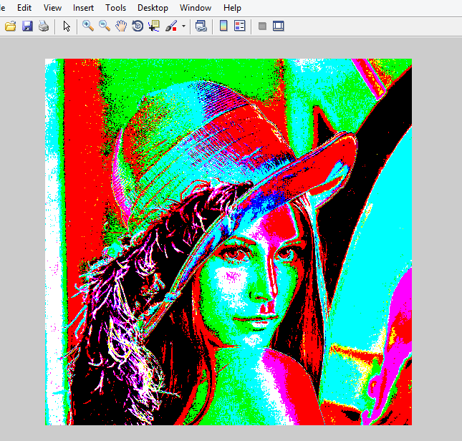 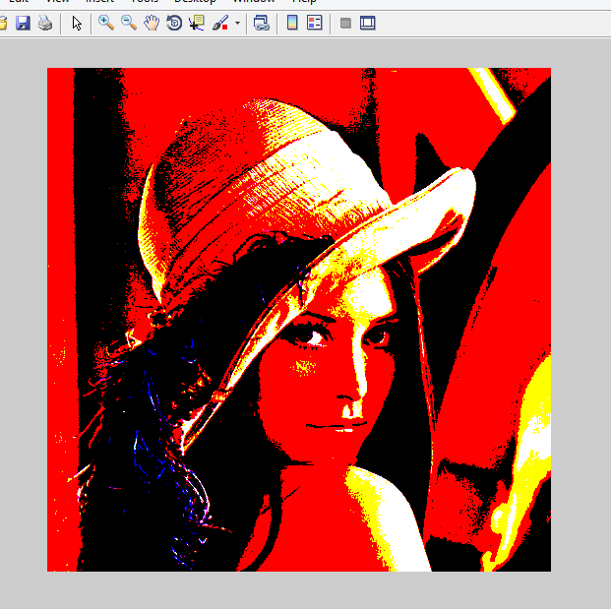

Histogram

x = imread('C:\Users\Ashish Verma\Desktop\LEENA.png');

img1= rgb2gray(x);

figure, imshow(img1);

title('original image');

%grayImg=mat2gray(x);

figure, imhist(img1);

title('histogram');

 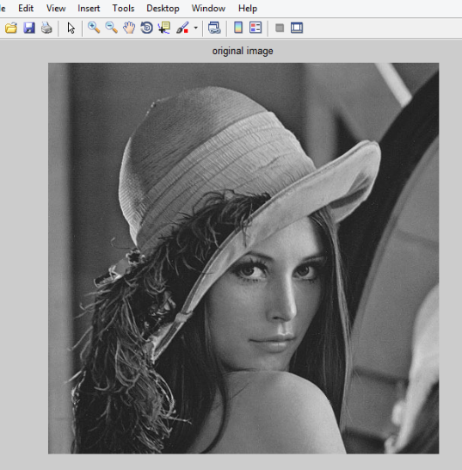

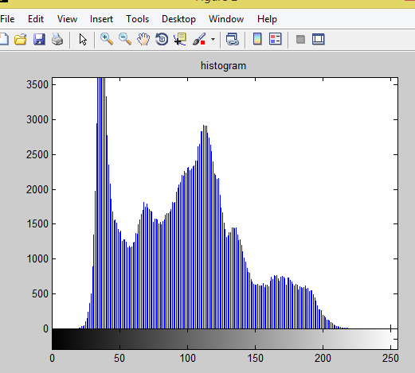

IV. CONCLUSIVE DISCUSSION

Image segmentation is a process of dividing an image into its constituent homogeneous regions to extract data from the attributes of the image. As a result, a good segmentation should result in regions in which the image elements should have uniform properties in terms of brightness, color or texture etc. Though the image is to be portioned into regions, the considerable changes within the regions should be observable visually. The measurement of quality of segmentation is that the elements of the same region should be similar and should have clear difference between elements of the other regions.

The segmentation process can be divided into various category based on the parameter selected for segmentation like pixel intensity, homogeneity, discontinuity, cluster data, topology etc. Each approach has its own advantages and disadvantages. The result obtained using one approach may not be the same as compared with other approach. Methods that are specialized to particular applications can often achieve better performance and this selection of an appropriate approach to a segmentation problem can be a difficult dilemma.

Basically the segmentation can be semi-interactive or fully automatic. The algorithms developed for segmentation lies in either of this category. With the major difficulty of ill-posed nature of segmentation it is hard to obtain single answer for segmentation of given image as the interpretation varies from individual approaches. In some cases manual interaction to segment the image may be error-prone (for example, in case of seed selection) while the fully automated approach can give error output (for example in case of watershed segmentation)and in some cases interactive methods can be laborious and time consuming. So a single approach to segment all variety of images may be practical unachievable. The prior knowledge on the image can give better results and gives user the choice to decide proper method to segment the image